Grade Level for the Classroom:

This classroom was designed with a Pre-K age group in mind. However, could be used/modified to fit a Kindergarten classes learning experiences.

Philosophy/Rationale for Experiential & Project Based Learning:

My teaching philosophy is continuously changing and growing throughout my own learning and personal journey. I believe that students benefit and are capable of independently exploring their environments, learning through open-ended materials and experiences, identifying their interests and making decisions about their learning. A large part of my teaching philosophy as an inspiring early childhood educator is based upon my view of children as competent human beings capable of being active participants in their learning journey. My beliefs are similar to what Loris Malaguzzi would describe as the ‘rich’ child: “an active learner, ‘seeking the meaning of the world from birth, a co-creator of knowledge, identity, culture and values’; a citizen, the subject of rights not needs; and born with ‘a hundred languages’” (Moss, 2010, para. 3). I hope to embrace and communicate this belief by transmitting an experiential learning experience – learning through doing. With this in mind, I hope to provide many hands on learning experiences that suit the classes unique needs, interests and identities within my future classrooms. I believe that this is can be achieved by allowing the children to engage in learning by play. Theorist Stuart Brown suggests that “play helps us reach our maximum developmental and neurological potential by contributing positively to our physical, emotional, psychological, [social] development[,] … creativity, optimism, and innovation” (Wood, 2014, p. 52). While class community gatherings and planned activities will take place daily, I hope to allow optimum amounts of time for students to engage in self-directed play. This form of play is described by Schwarzmueller and Rinaldo (2013) as occurring “when physical or mental activity is pursued to satisfy personal inclinations, such as curiosity, or the collective inclinations of a group of playmates” (pp. 37-38). I believe in creating open-ended learning experiences (i.e., leaning invitations without a specific end project in mind, access to arts material to create art without prompts, etc.) and supplying children with open-ended materials. An example of open-ended materials are loose parts. Dillon (2018) describes receiving a bag of loose parts from a Reggio Emilia breakout session, which contained “the following items: a straw, some small wooden circular pieces, a few small buttons, a number of cupcake holders, a variety of colorful wooden pieces, a small square of tinfoil, some random foam shapes, and pink and black feathers” (p. 64). While the items may seem simplistic and random, the author describes her children as becoming engrossed in the play experience upon receiving them. I believe in paying attention to the students play experiences, the interests they seem to have and learning materials that students seemed to have outgrown. These “observations of children’s interests, developmental themes, family life, and culture can guide your selection of materials” and future planning (Curtis & Carter, 2008, p. 69). Further than student interests, it is important to honour all learners and families within the classroom through direct and indirect lessons. For example, “materials that accurately … reflect … [different] racial and ethnic identity groups, … a range of economic groups perfomring all types of work [and] … divers family structures (Derman-Sparks & Edwards, 2010, p. 43). That being said, my teaching philosophy is heavily influenced by an anti-bias education approach. My hope for my future learners is to provide them with “a world that recognizes all people for the unique, fully human beings they are; a world where every child has equal access to the opportunities to become all he or she can be” (Derman-Sparks & Edwards, 2010, p. 30).

Educator Role in the Classroom:

Educators have a complex role in students lives; they “need to be set designers who create the environment in which activities take place. At the same time, the teacher needs to the audience who applauds” (Moss, 2010, para. 34). I imagine myself having a role of a guide, supporter, more knowledgeable other (Vygotsky) and creator of the environment for my unique learners. As the educator, I must understand that each “child is already tightly connected and linked to a certain reality of the world – she has relationships and experiences [that she cannot be separated from]” (Malaguzzi, 1994, para. 17). My role is to analyze these realities (for each individual class) and incorporate my findings respectfully into the classroom and lessons. As an inspiring anti-bias educator, I must “include all children in activities, stories, discussions and experiences that expose new ways of cooperating, new information about cultural understandings, practices or languages and additional ways of supporting each other” (Ministry of Education, 2008, p. 18). I believe it is my role to create an environment that “anyone who enters [my] classroom can tell immediately who is in your program[,]” which contains “materials that honor diversity both within and beyond [the students] own identity groups” (Derman-Sparks & Edwards, 2010, p. 43). To construct my environment necessary for optimum learning, I must “honour the families’ role as children’s first teachers and collaborate with them to provide consistent support and culturally sensitive learning opportunities” (Ministry of Education, 2008, p. 18). I believe it is my responsibility to go above and beyond when creating relationships with all individuals involved in my learning community. Beyond healthy relationships allowing all to feel welcome and invited into the classroom, the bonds act as great resources when respectfully including topics that are unfamiliar to the educator. It is my role to supply the students with correct information and language about the world around them, while understanding that their “questions about their own and others’ various identities and appearance reflect their desire to make sense of their world” (Derman-Sparks & Edwards, 2010, p. 33). My role “is to provide guidance towards learning objectives” (Schwarzmueller & Rinaldo, 2013, p. 40) through learning invitations and open-ended learning explorations.
I believe that my role is a large, but passive one. I am a facilitator, a friend, a comfort and a cheerleader. In a house, I am the plumber, the cook, the electrician, the entertainer, and cleaner. The students are the stars the occupy, experience and learn in the environment I have thoughtfully designed. My role seems complex and dominating, but the student’s role is just as large and important as mine in creating the learning experience. On a movie set I am the set coordinator, the lighting technician and the designer, while the students remain the stars. However, the students and I are a team when it comes to writing the script and directing the film.

Inspiration:

While observing in an early learning center in ECS 200, I experienced a classroom environment unlike anything I had ever experienced before. The classrooms I had experienced as a child were very similar to what Tarr (2001) had described general North American Classrooms looked: materials were commercially made, bright colours and cluttered plastic furniture caused sensory overload, and the students were not authentically represented in the environment. That being said, I remember wonderful things about my educators and appreciate their part in my learning journey. On the other hand, the early learning center in Regina had a natural and calm energy throughout the property (inside and out). The classroom (pictured below) I was observing in had a very fortunate layout: an attached washroom, an attached spare closet/room used as a quiet area and a wall of windows. I incorporated a washroom into my classroom (as most early childhood centers have attached/shared washrooms) and a wall of windows, though nothing about my design would change without those aspects. I realized it was relatively unrealistic to think I would have a bonus room for a quiet space, but was inspired by the benefits I observed. I sectioned off an area of my classroom to realistically incorporate a quiet area, as you will see in the next section. The classroom I observed in flooded with natural light, was filled with plants and had an easy flow throughout the space. I believe that the welcoming aspect of both the environment and educator allowed for an easy transition from home to school and created bonds between the adults and children of the learning community. Further, the educator always referred to her, the students and all others in the facility as friends. She created a seemingly equal relationship, in what is typically unbalanced. I was inspired by the environment and presence of the educator, and it can be seen within my dream classroom (and role within it).

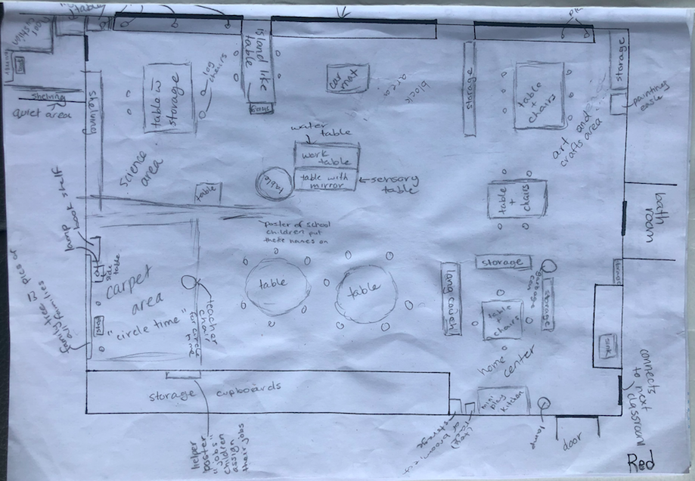
Visual Representation of Classroom Design:

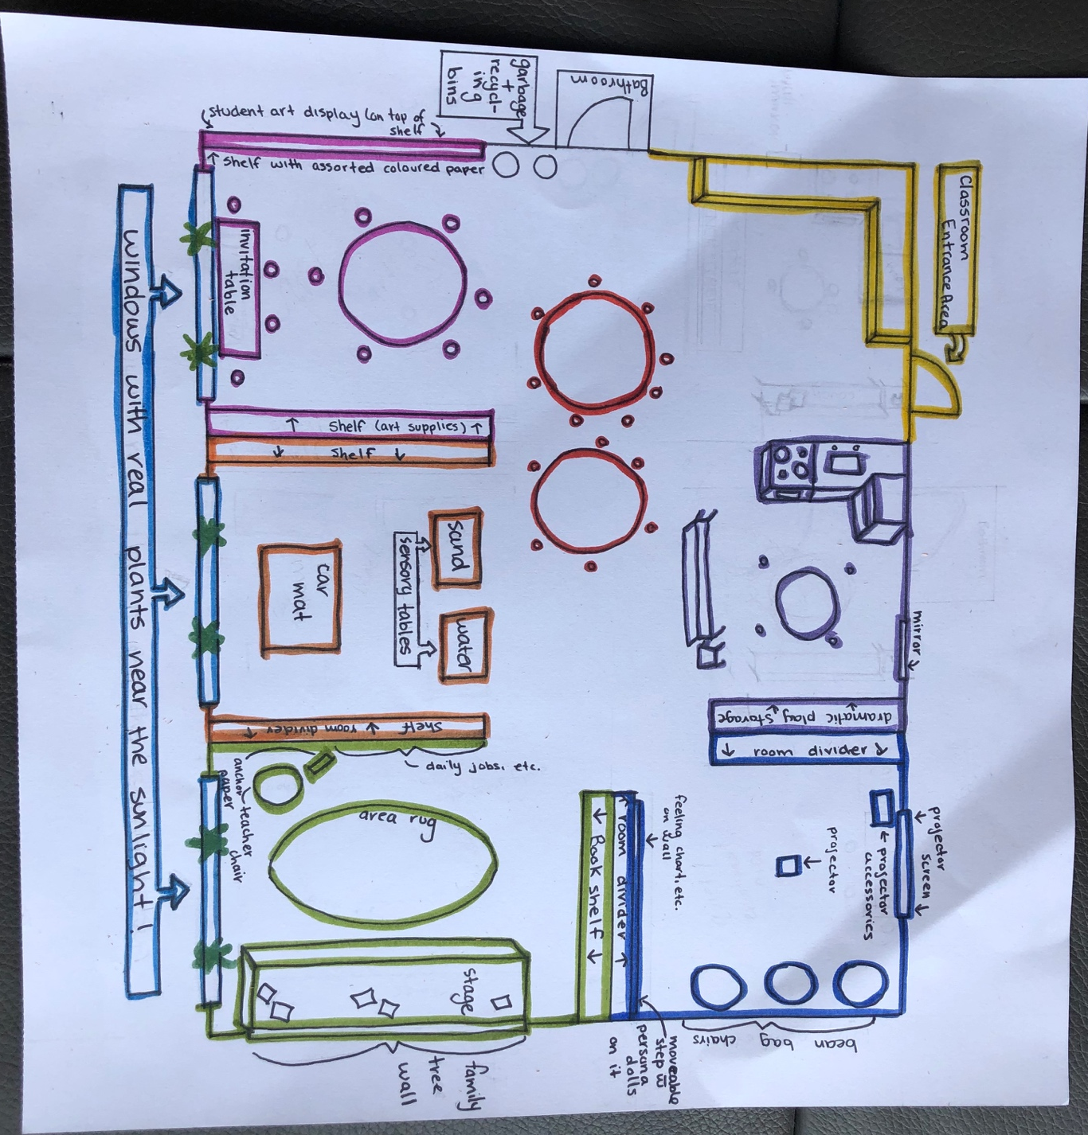

Description of Spaces in the Room:
In General: I have colour-coordinated the areas on my classroom floor plan visual representation and titles of the sections of the descriptions of the spaces in the room. Please note that I envision all shelves to be less than 4 feet tall, aside from the more secluded quiet area. Further, I am not an artist!! The quiet area is represented a lot larger than I envision it to be in reality. For example, I would make the dramatic play area larger than the quiet area. Below I will have described a specific environment, I believe in flexibility within the environment (with consideration of permanent aspects of the building). With careful consideration the environment can act as a third educator, as described in the schools of Reggio Emilia (Tarr, 2011). As described above, I believe in honouring diversity within and beyond the learning community. I have planned for my environment to contain “materials that accurately … reflect … [diverse] racial and ethnic identity groups, … a range of economic groups preforming all types of work [and] … diverse family structures” (Derman-Spark & Edwards, 2010, p. 43). I will utilize the nature around us within lessons and materials. For example, going on a nature walk to collect supplies for the arts area in the classroom. “Not only are natural items great learning tools but they also enhance the space with beauty” (Wood, 2015, p. 14). I will arrange my “manufactured and natural materials … in transparent containers” throughout my classroom. This will allow children to clearly see the individual uses of materials and the aesthetically appealing nature of the classroom will “[communicate] respect for the children and the importance you place in the activities you offer” (Curtis & Carter, 2008, p. 75). Along with free access and choice in materials to utilize in the environment, the children have diverse working spaces to allow the children to think and work in. “The key is access – access to a range of working spaces, access to materials, access to other children and other adults” (Hubbard, 1998, p. 29). The free access, diversity in materials and the organized appeal of diverse materials in clear containers would be apparent in my future classroom (and how I imagine this one would look in reality).
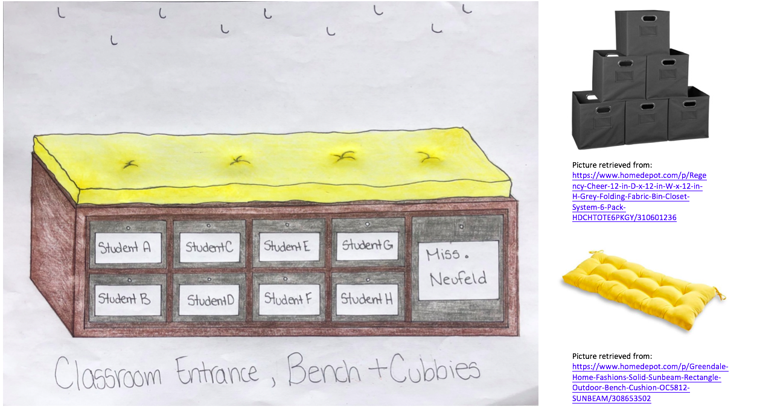
Classroom Entrance:
The entrance and classroom cubby area of the classroom is one with brief interactions, but essential for the organization and function of the classroom. Within this ideal classroom situation, the students have their own locker area outside of the classroom for their backpacks, outdoor wear and so on. These cubbies will simply act as storage for classroom materials such as work books, indoor shoes, and so on. I imagine filling the hooks with thrift store, big shirts to protect children’s clothes during messy play (art, water table, etc.). This is suggested by Derman-Sparks and Edwards (2010), as “it may be very difficult for lower-income families to purchase new clothes, and washing clothes can require spending many hours (and dollars) in Laundromats” (p. 106). I used a bright, comforting colour (and personally one of my favourites) to welcome the students into the classroom. Note: I would use a dull yellow, opposed to bright and bold. The activities in this area would consist of putting on shoes, preparing for art (with the long sleeve shirts), grabbing work material and so on. In making this area an inviting area in which students see themselves, the class must be engaged in decorating name tags for their individual cubby. This idea is inspired by the idea of personalizing the classroom to suit the unique learners the educator is learning alongside. “Because the physical environment begins with who children are, each early childhood classroom will have it own unique look” (Derman-Sparks & Edwards, 2010, p. 43). There will be no specific materials found in this area besides mess play protective wear and class work materials.

Classroom Tables:
Tables without any specific activity attached to them, a community area

This area of the classroom, between the entrance and the art area, is simple and in a general area of the environment. These tables may be left for free use during play, used by the entire class during meal or snack times, or be used for student directed group meetings. As encouraged by the Ministry of Education (2008), children need “spaces for small, active groups” (p. 3) and spaces for “comfortable, large group meetings” (p. 13). There would be no materials designated for this area, but the space could be used for learning invitations (which would then need materials).

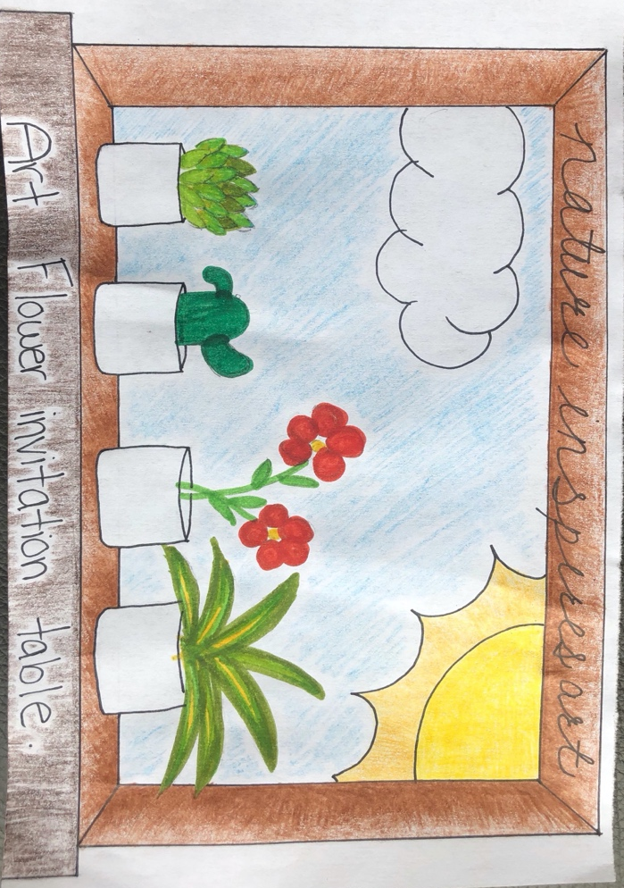
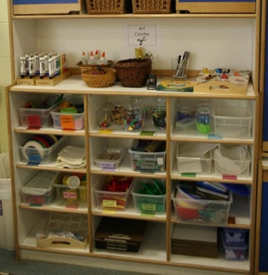
Picture retrieved from: https://www.google.com/search?q=cupboard+of+assorted+coloured+paper&tbm=isch&ved=2ahUKEwjn5deDgfPoAhUC0KwKHbW-CSEQ2-cCegQIABAA&oq=cupboard+of+assorted+coloured+paper&gs_lcp=CgNpbWcQAzoECCMQJzoECAAQQzoCCAA6BggAEAUQHjoGCAAQChAYOgYIABAIEB5Q7zFYk15g1V5oAnAAeACAAdABiAGvI5IBBjAuMzUuMZgBAKABAaoBC2d3cy13aXotaW1n&sclient=img&ei=Bn2bXufKBIKgswW1_aaIAg&bih=694&biw=843#imgrc=4cCNv6GO3jgSyM

Picture retrieved from: https://www.google.com/search?q=art+supplies+in+pre+k+classroom&tbm=isch&ved=2ahUKEwiNr9XcgfPoAhVGWKwKHWKYApgQ2-cCegQIABAA&oq=art+supplies+in+pre+k+classroom&gs_lcp=CgNpbWcQAzoECAAQQzoCCAA6BAgAEBhQsy5Yz0Bg9UFoAHAAeACAAYABiAHYEZIBBDAuMTmYAQCgAQGqAQtnd3Mtd2l6LWltZw&sclient=img&ei=wH2bXo3PKcawsQXisIrACQ&bih=694&biw=843#imgrc=JsZb9EnfeohPZM

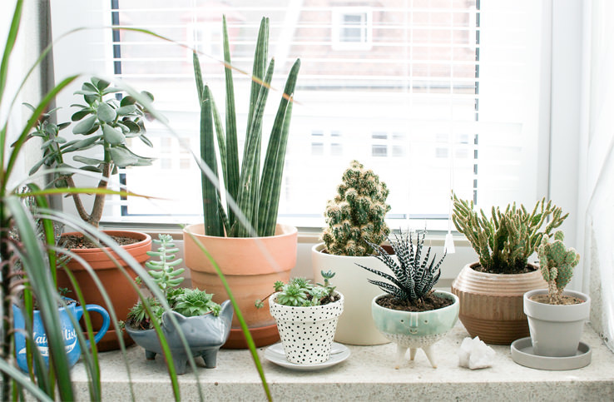
Picture retrieved from: https://www.google.com/search?q=window+sill+with+plants&sxsrf=ALeKk03YF7XP9g7vtTdkKdAoDvVgt0v9hg:1587248170640&tbm=isch&source=iu&ictx=1&fir=U_jm2Fo9o69NsM%253A%252CjNrLLyZ749-DUM%252C_&vet=1&usg=AI4_-kRLif0QK7j_iJnd3dAz-1mTwl1ohg&sa=X&ved=2ahUKEwiUkoabgPPoAhXHVc0KHe9nDjcQ9QEwB3oECAsQKg#imgrc=4e8dfXckarDgBM&imgdii=gNbKgHyesF2HlM

Creative Art Exploration Area:
An area for free art expression and exploration, with the addition of a learning invitation table

The arts and creation area of the classroom acts as a place to inspire wonder and
creation. Ideally I would like to be placed in a classroom with access to windows, as nature is truly inspirational when it comes to art. However, if I am not blessed with a classroom filled with natural light, I will still bring plants into the classroom. I will supply students with materials from nature, and use lessons surrounding the idea of nature to try to embody the outdoors within the classroom. Art is much larger than arts and crafts. As Massey (2017) suggests, “art becomes not just a product to take home; it embraces nearly every experience in the classroom, from building with blocks to creating composition on the light table” (pp. 8-9). While art may take place anywhere in the classroom, this area will act as the source. The Ministry of Education (2008) suggest an arts area, or “representation areas (painting, drawing, sculpting, writing…)” (p. 13) supports muscle development. Further this area will act as a “display of children’s projects and creations” (Ministry of Education, 2008, p.3).
I imagine a diverse population of materials available for students use in this area.
Hubbard (1998) suggests that “[children] need ready access to [art materials] [(paper, clay, pastels, paints, watercolours, charcoal crayons, easels, clipboards, pads, sketchbooks)], since each artist might be working with different medias” (p. 30) and at different stages. Further, the materials (paper, markers, paints, etc.) will come in all shades of colours – including skin colours. Further, not a single shade will be identified as skin colour. It is important that all children can see themselves within the materials in this section (especially if engaging in a portrait project) and understand that “all colors, shades, and shapes of people are beautiful” (Derman-Sparks & Edwards, 2010, p. 83). I hope that carefully thought out supplies, like diverse skin colour options, allow students to further develop and embrace their racial identity. Further, I will always use alternatives for food within arts projects as I realize that food is a luxury and not for wasting (Derman-Sparks, 2010).
I imagine this area being a place where many activities can take place. I have included a
permanent invitation table, though the learning activity will change throughout the year. Curtis and Carter (2008) suggest that invitations can help “children create initial ideas about how to get started with the materials and may also encourage them to do something they [or the educator] might not have considered” (p. 80). I have included my Invitation from the previous assignment as part of the set up of my classroom in this assignment. Though I imagine a self-portrait invitation and so on would be just as successful in this area. I would base the following invitations on the curiosities and interests of the students. I imagine many forms of play taking place in this area. For example, the Ministry of Education (2010) describes several versions of involved play behaviour that I think would become a reality in this area: “solitary in which the child plays alone; parallel in which the child plays beside or near other players but does not play with anyone; [and] associative in which the child plays and talks with other players but the purposes or forms of the play may not be the same” (p. 3).

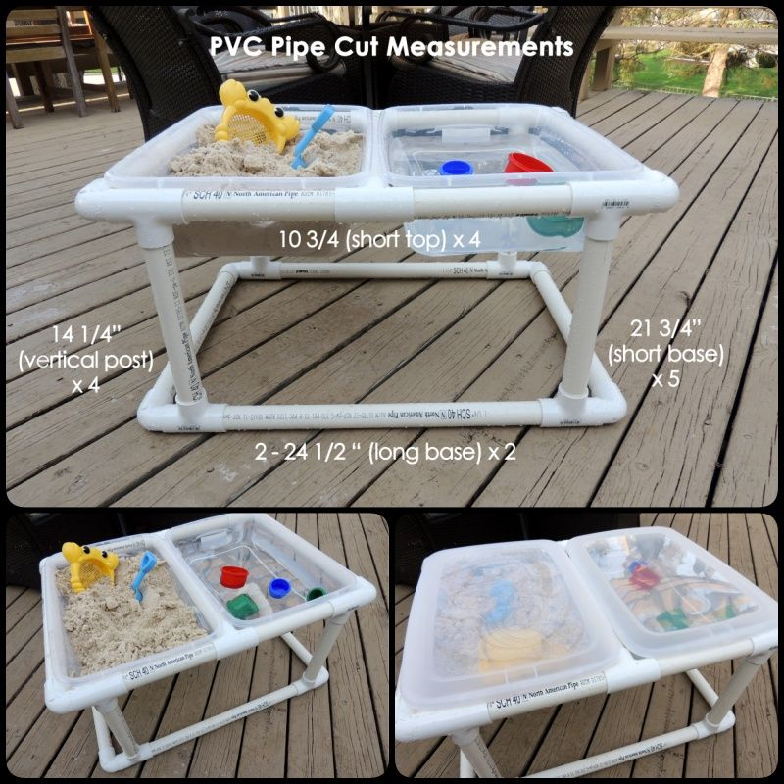
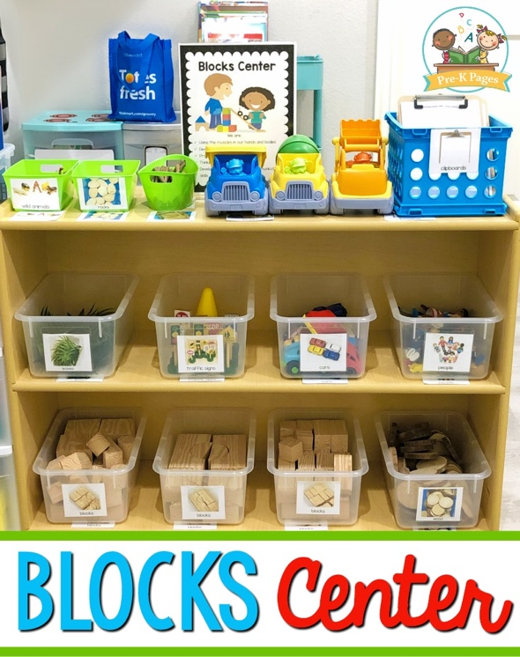
Picture retrieved from: https://www.google.com/search?q=transparent+bins&tbm=isch&chips=q:transparent+bins,g_1:plastic:_nPBdFtIevk%3D&hl=en&ved=2ahUKEwjNkq72rPPoAhWMna0KHd0ZCmAQ4lYoAHoECAEQFQ&biw=843&bih=694#imgrc=lUWRuKcOYybB1M

Picture retrieved from: https://www.pre-kpages.com/blocks_center/

Science/Constructive Play Area:
This area will act as the block, car and sensory table area
DIY instructions & picture retrieved from: https://coolcreativity.com/handcraft/how-to-make-a-pvc-pipe-sand-and-water-table/

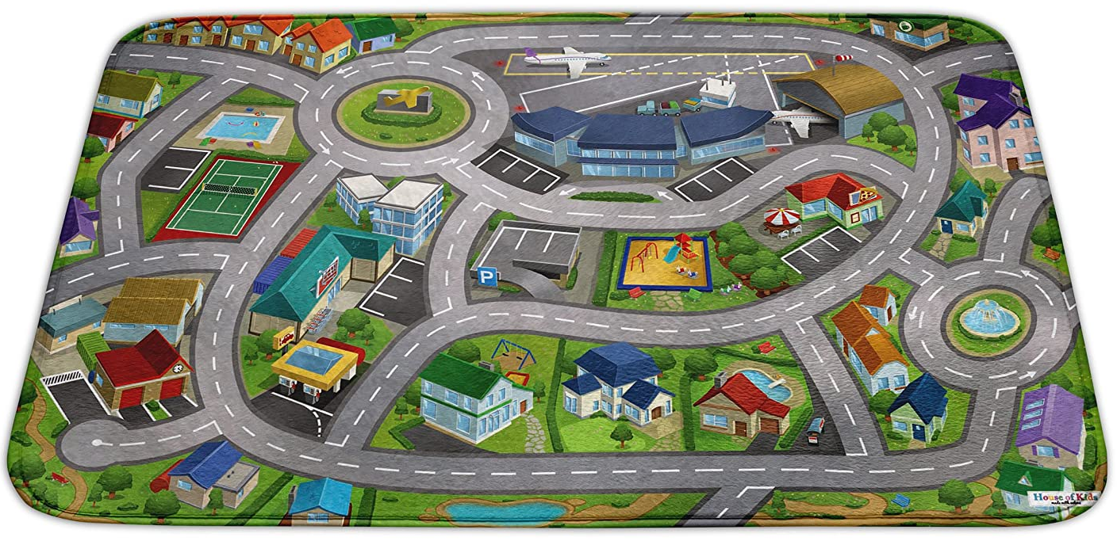
Mat can be bought at: https://www.wayfair.ca/Zoomie-Kids--Boswell-Driving-Time-Area-Rug-aNJF6696-L167-K~ZMIE5585.html?refid=GX422771789279-ZMIE5585_24168845&device=c&ptid=386959395565&targetid=pla-386959395565&network=g&ireid=22511546&PiID%5B%5D=24168845&gclid=Cj0KCQjwyur0BRDcARIsAEt86IByylJ6WzCGoAv-Rqnr3hKxIXTFpc9TBTCiCIYHoQZ_DNGbthPtd6oaAkBtEALw_wcB

I imagine this area being a place of discovery and exploration of the world of physics and
constructive play. There are many options for play in this area of the classroom and many I recognize from my own childhood. From building blocks to cars and a mat, there are many open-ended experiences available in this area. The items would be organized by similarity in clear boxes located on the shelves. A community car mat would lie on the ground and two sensory bins would stand in this area. The sensory bins would change from time to time to ensure continued curiosity. As mentioned above, the bins would not contain any food substances (Derman-Sparks & Edwards, 2010). This would be an area that “[encouraged] interaction and relationship building” (Ministry of Education, 2008, p. 3).
The materials in this area could be endless. From loose parts, as described by Dillon
(2018) to aspects from nature, like rocks and sticks. I imagine toy cars that represent all types of work like Derman-Sparks and Edwards (2010) suggest for an inclusive learning environment; for example, fire trucks, garbage trucks, taxis, buses, delivery drivers, etc. Wooden blocks for construction of bridges and buildings could be found amongst the shelves. There would be materials (scoops, molds, etc.) available in the sensory bins.
Like the materials, the activities could range in this area. The students would typically be
involved in all forms of involved play described in the section above, but they would also be engaged in a form of cognitive play: Constructive play. This form of play is described as the “use of blocks or materials to make something” (Ministry of Education, 2010, p. 3). By allowing free time with blocks, the educator may allow students to think like engineers. Further this allows students to further develop their gross and fine motor skills. “They practice gross and fine motor skills by carrying large, heavy blocks and balancing smaller blocks on top of each other, and they explore different shapes and sizes of blocks and other materials” (Christenson & James, 2015, p. 28). Further access to ramp building materials (wooden blocks) and super fast race cars (toy cars), students can engage in motion and mass exploration as described by Trundle and Smith (2011).

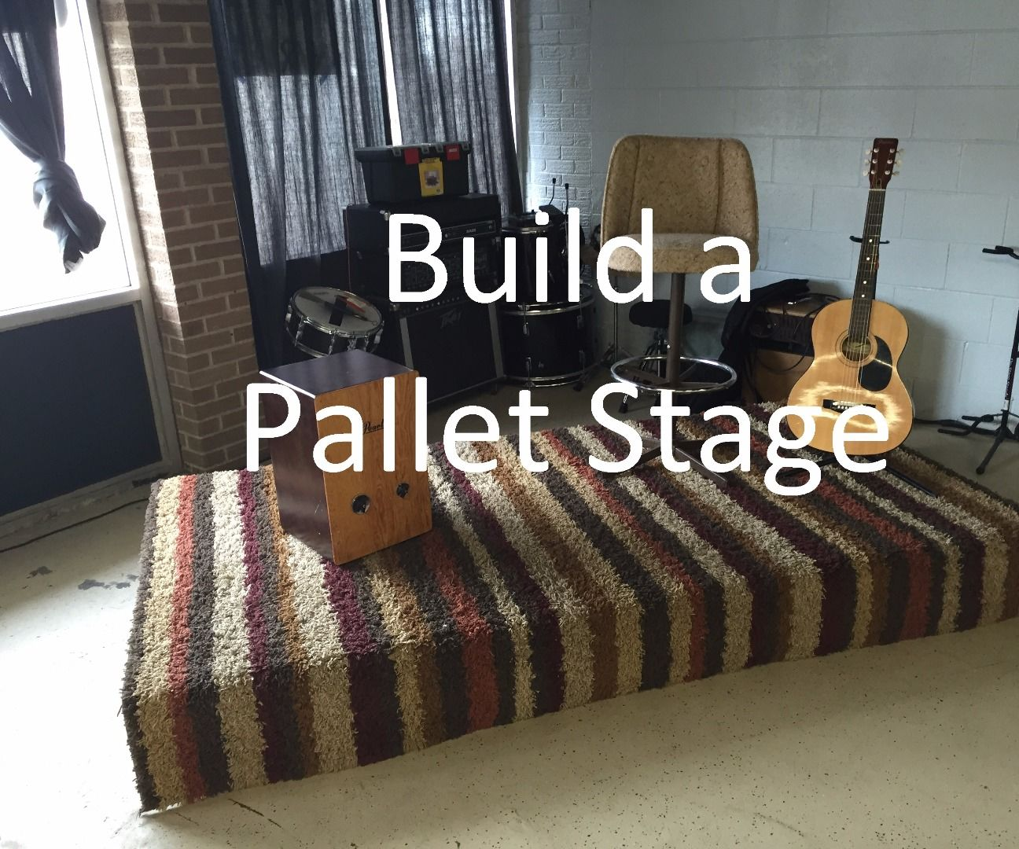
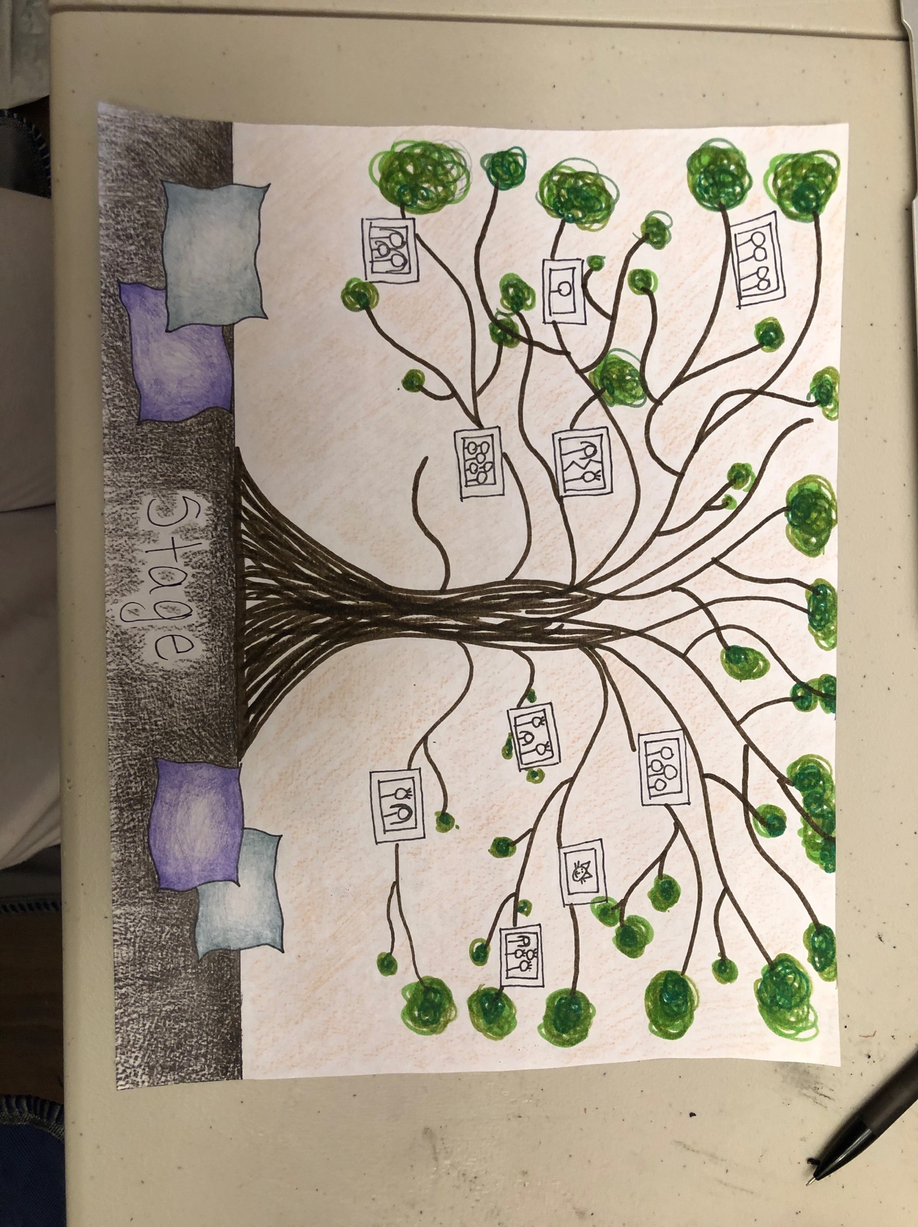
Instructions for a DIY stage: https://www.instructables.com/id/Pallet-Stage/

Reading Area/Class Library:

I imagine this space being used for classroom gatherings, reading books and learners
(and their families) place to see themselves in. “The walls hold the history of the life within the school” (Tarr, 2001, p. 38). This area will have a room divider filled with calendars, daily jobs, attendance and so on. There will be a teacher chair and anchor chart paper along the wall with daily posters. The teacher chair will be pointed toward a moveable stage (DIY with palettes, etc.). Ideally, the stage would have a ramp to meet the needs of all the abilities present in the classroom as encouraged by Derman-Sparks and Edwards (2010). The ministry of education (2008) further suggests to utilize “adaptive design features to accommodate persons with a mobility or physical ability” (p. 3). The platform will further “expand the sense of available space” in the area (Curtis & Carter, 2005, p. 36). Further the Ministry (2008) suggests that spaces such as these “support muscle development [as a] comfortable, large group meeting [place]” (p. 13).
The materials in this area would contain items of comfort (blankets, pillows, etc.) and a
diverse range of books. Typically books depict middle class, White, American nuclear families accomplishing some sort of challenge. While many of these are fantastic additions to a collection, they should only be some of many. “The visual and verbal messages young children absorb from books (and other media) heavily influence their ideas about themselves and others” (Derman-Sparks, 2016, para. 1). With this in mind, I will provide books depicting many ways of knowing, “various social identities (e.g., racial, ethnic, gender, economic class, sexual orientation, and disability)” (Derman-Sparks, 2016, para. 1).
I imagine this area holding the daily activities, more specifically the morning activities.
When students arrive, I hope to engage the students in a group discussion about who is present, how they are doing, what they day will look like and their personal responsibilities of the classroom (if they decide to want one that day). Having a ritual like this proves to have benefits for the students as well: “having it every morning at the same time, the children know what they’re going to be doing; it’s something they can count on” (Hubbard, 1998, p. 27). Further, I will use this time to analyze how the students are feeling each day and accommodate to those feelings. This space will be used to read books introducing the learning invitations present in the environment (i.e., the flower invitation in the arts area) and to discuss the day. “Daily calendar time indicates a predictable time to experiment with numbers … children and teacher come together to mark off days on the calendar and explore the numbers and patterns that exist” (Hubbard, 1998, p. 28).

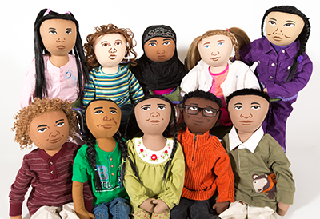
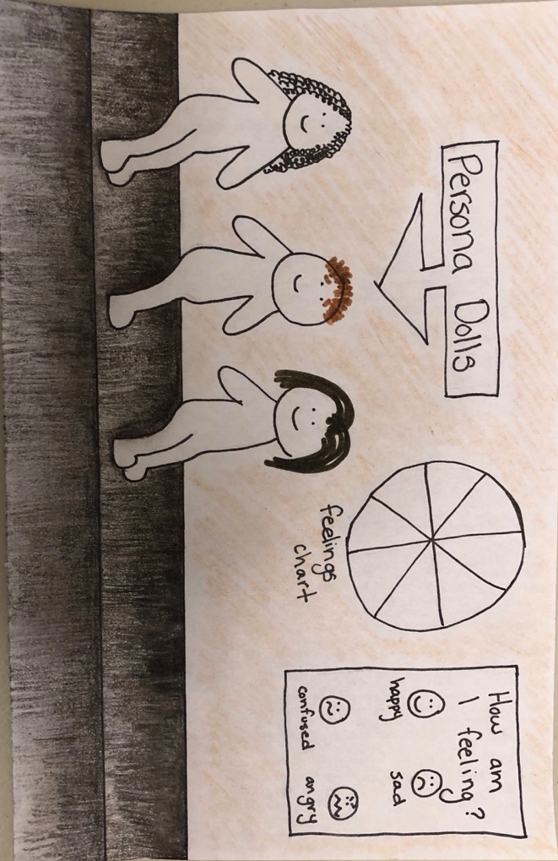
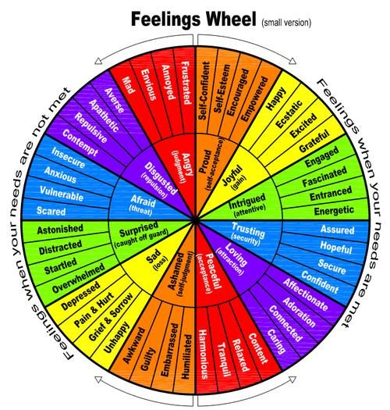
Picture retrieved from: https://www.google.com/search?q=persona+dolls&sxsrf=ALeKk01Tb_q6_cotHpefjskPy6j59oZedw:1587324044127&source=lnms&tbm=isch&sa=X&ved=2ahUKEwjHnqzumvXoAhWXGc0KHQyBBtsQ_AUoAXoECAwQAw&biw=843&bih=694#imgrc=RS82nNIQDQmtqM

Picture retrieved from: https://www.google.com/search?q=feelings+wheel&sxsrf=ALeKk017DJ8WkQf3I-Fj2to726D3Dkk6sQ:1587323884815&source=lnms&tbm=isch&sa=X&ved=2ahUKEwid0rCimvXoAhUEH80KHQx9BXIQ_AUoAXoECBAQAw&biw=843&bih=694#imgrc=p1fwzyEnx1Ow7M

Quiet Area:

Growing up, I was never given access to a space that was designated for quiet thought,
calm activities or any space to really identify how I was feeling (through thought, conversation, etc.). I never knew what persona dolls were and the amazing benefits they have when used correctly. Honestly, I never thought about including a quiet space in a learning environment. That changed through my observation assignment in ECE 200. When students were having a hard time moving from their home environment to the (most likely different) school atmosphere they utilized the cozy, quiet area to feel and understand their thoughts, emotions, etc. – they may be experiencing culture shock (Derman-Sparks & Edwards, 2010). Further, the Ministry of Education (2008) suggests including a “private, quiet [space] for talking, thinking and planning” (p. 3). Curtis and Carter (2005) further support this thought as they suggest including “protected areas out of the main flow of the larger classroom [allowing] children opportunities to have focussed discussions and work cooperatively” (p. 37). I imagine this secluded space dimly lit with comfy bean bag chairs available, persona dolls to play alongside, a projector for calm light sensory play, and emotion charts (etc.) to allow students to understand and identify their emotions.
The materials in this room would consist of comfy seating, a moveable step (adding
dimension to the space), a projector (and accessories), feelings charts (etc.) and persona dolls.
The persona dolls would be placed on the step, giving them their own platform to sit on. Opposed to dolls you play with being placed on a shelf, these dolls will have their own seat (as if they are children) on the step. “When you change the scale of similar materials and offer them on different surfaces with different levels, children have more opportunities to use the materials in new ways” (Curtis & Carter, 2008, p. 79). I would begin by introducing the dolls identity as another friend in the classroom, then continue to tell the students stories of experiences their new friend (the persona doll) has gone through, as suggested by Derman-Sparks and Edwards (2010). My collection of dolls would include “some reflecting the specific children and families in your classroom and others introducing new kinds of diversity” (Derman-Sparks & Edwards, 2010, p. 49). The light sensory station would act as a quiet, clean and calming sensory activity within this space. The children could stimulate their minds and senses while surrounded by a peaceful environment. I believe children “have a wide range of strong emotions and deserve chances to express their feelings and receive respect” (Curtis & Carter, 2005, p. 35).
I imagine the activities in this area being completely student directed. I will not arrange
any activities in this area. The students may utilize the area in any way they see fit. Whether that be playing alongside the persona dolls, drawing the designs they created on the projector, or analyzing the feelings chart for further emotional development, the control is in the students hands.

Dramatic Play Area:

This dramatic play area will be filled with objects many students would find in their own
home such as, a couch, phone, kitchen area and so on. This environment will “promote children’s social development through design features that invite dramatic play, collaboration in projects and relationships with peers and adults” (Ministry of Education, 2008, p. 12). Further, it is an area that “[encourages] interaction and relationship building” (p. 3) amongst peers. While Curtis and Carter (2005) explain that early learning centers were preferably operated in a home setting, I have included a home setting in the school. The area will have a child size kitchen, a couch, telephone, (culturally appropriate) dress up materials, kitchen accessories and so on.
The materials in this area will promote imagination amongst the diverse families in the
learning community. The parts within the area provide small muscle development. Some examples of these parts include “house keeping objects such as spoons for mixing, containers for scooping, teapots for pouring, telephones for dialing and shoes and capes for dress up” (Ministry of Education, 2008, p. 12). I will invite the guardians to bring or suggest materials to fully represent the diversity in (and beyond) the classroom. Further, I will learn from my students and their assumed interests based on the play in this area.
The activities in this area, amongst the rest of the areas in the classroom, will be student directed. However, I will set up learning explorations in this area.
An example given by Beloglovsky (2018) in her discussion about play equity, she
describes reaching out to members in her community to represent diverse cultures home life within her dramatic play area. I have learnt from this suggestion and plan on introducing learning experiences similar to this. I will reach out to all my students, collegues and other community members for a dinner table layout, how to respectfully interact with the display and any background knowledge needed. I imagine the students being engaged in involved play (solitary, parallel, associative and cooperative). They will be engrossed in pretend play experiences. The Ministry of Education (2010) describes the benefits the play that could be seen in this area as, “[enhancing] reasoning and problem solving abilities” (p.3). They further suggest that an area like this would engage the students in Cognitive play (the use of imagination and role play) and socio-dramatic play. In this typical early childhood play, “children represent their fowing understanding of the world through their body language, spontaneous oral language and vivid imagination” (Ministry of Education, 2010, p. 4).

References:

Beloglovsky, M. [San Francisco Public Library]. (2018, Apr 19). Miriam Beloglovsky “Play Equity” at the San Francisco Public Library [Video File]. Retrieved from https://www.youtube.com/watch?v=IovZyfq77AQ.

Christenson, L. A., & James, J. (2015). Building bridges to understanding in a preschool classroom: A morning in the block center. Young Children, 70(1), 26.

Curtis, D., & Carter, M. (2005). Rethinking early childhood environments to enhance learning. Young Children, 60(3), 34-38.

Curtis, D., & Carter, M. (2008). Enhance the curriculum with materials. Learning together with young children: A curriculum framework for reflective teachers (pp. 54-85). St. Paul: Redleaf Press.

Derman-Sparks, L. (2016). Guide for selecting anti-bias children’s books. Teaching for Change. Retrieved from https://www.teachingforchange.org/selecting-anti-bias-books.

Derman-Sparks, L., & Olsen Edwards, J. (2010). Anti-bias education for young children and ourselves. Washington: National Association for the Education of Young Children.

Dillon, A. (2018). Finding Innovation and Imagination in a Bag of Loose Parts. Childhood Education. 94. 63-65. 10.1080/00094056.2018.1420369.

Hubbard, R. S. (1998). Creating a classroom where children can think. Young Children, 53(5), 26-31.

Malaguzzi, L. (1994). Your image of the child: Where teaching begins. Exchange, 3, 1-5.

Massey, K. J. (2017). Art at the heart: Creating a meaningful art curriculum for young children. Young Children, 8-13.

Moss, P. (2010). What is Your Image of the Child in UNESCO Policy Brief on Early Childhood. Institute of Education, London.

Saskatchewan Ministry of Education. (April 2008; reprint 2013). Play and exploration: Early learning program guide.

Saskatchewan Ministry of Education, Government of Saskatchewan. (2010). The Importance of Play. pp. 1-6). Retrieved from https://urcourses.uregina.ca/pluginfile.php/1959416/mod_resource/content/1/importance_play.pdf

Schwarzmueller, G., & Rinaldo, V. (2013) The importance of self-directed play. Kappa Delta Pi Record, 49(1), 37-41

Tarr, P. (2001). Aesthetic codes in early childhood classrooms: What art educators can learn from Reggio Emilia. Art Education, 54(3), 33–39.

Trundle, K. C., & Smith, M. M. (2011). Let it roll: Exploring motion with young children. Science and Children, 49(2), 38.

Wood, L. D. (2014). Holding onto play: Reflecting on experiences as a playful K-3 teacher. Young Children, 69(2), 48-56.

